

Name : Muhammad Abdullah
Reg # FA24-BSE-042
Instructor : Raheel Ahmed

Lab Report
Lab 12: Verify the Working of JK Flip-Flop (FF) & RS Flip-Flop (FF)
Digital Logic Design

2.2 The RS Flip-Flop (NOR Gate Implementation)
The SR (or RS) flip-flop is the simplest bistable circuit. It can be constructed using two cross-coupled NOR gates or two cross-coupled NAND gates. The NOR-based RS flip-flop has active-HIGH inputs (S and R), while the NAND-based version uses active-LOW inputs (S̄ and R̄).

NOR-Gate RS FF Truth Table (Active-HIGH):

S | R | Q (Next State) | Q̄ (Next State) | Operation
0 | 0 | Q (No change) | Q̄ (No change) | Hold / Memory
0 | 1 | 0 | 1 | Reset
1 | 0 | 1 | 0 | Set
1 | 1 | Forbidden | Forbidden | Invalid / Undefined

Key observations for the NOR-gate RS FF:
- S=0, R=0: The circuit holds its previous state (memory state).
- S=0, R=1: The flip-flop is RESET — Q goes to 0.
- S=1, R=0: The flip-flop is SET — Q goes to 1.
- S=1, R=1: Both outputs attempt to go to 0 simultaneously, creating a forbidden/undefined state that must be avoided.

2.3 Circuit Simulation — RS Flip-Flop (NOR Gates)
The following Proteus simulation shows the NOR-gate based RS flip-flop with S=1, R=1. The outputs P (≡Q) and Q are monitored via LED indicators.

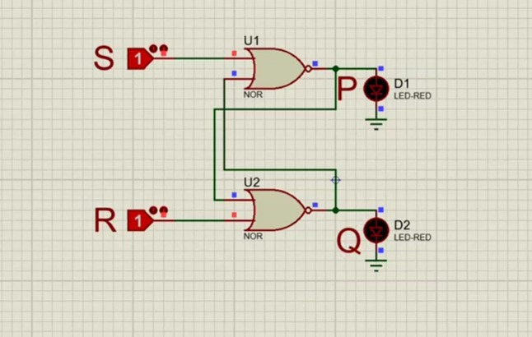
Figure 1: RS Flip-Flop using NOR gates (Proteus Simulation) — S=1, R=1

Simulation Analysis:
- In the simulation, S is set HIGH (1) and R is also HIGH (1).
- Both LEDs D1 and D2 are OFF, indicating both P (Q) and Q outputs are LOW — this is the forbidden state.
- In practice, this condition must be avoided as it leads to unpredictable behavior when inputs return to 0,0.
- The circuit correctly demonstrates the cross-coupled NOR gate behavior.

2.4 The Clocked RS Flip-Flop (Synchronous)
In digital systems, it is often necessary to synchronize flip-flop state changes with a clock signal. The clocked RS flip-flop adds two NAND gates at the input to gate the S and R signals with the clock. The flip-flop only responds to S and R when the clock (CLK) is HIGH.
Using NAND gates at the front end makes S and R active-HIGH in this configuration. The truth table below describes behavior on the nth clock pulse:

Clocked RS Flip-Flop Truth Table:

CLK | Rₙ | Sₙ | Qₙ₊₁ | Q̄ₙ₊₁ | Operation
0 | X | X | Qₙ | Q̄ₙ | No effect (clock disabled)
1 | 0 | 0 | Qₙ | Q̄ₙ | No change (hold)
1 | 0 | 1 | 1 | 0 | Set
1 | 1 | 0 | 0 | 1 | Reset
1 | 1 | 1 | Undefined | Undefined | Forbidden

2.5 The JK Flip-Flop
The JK flip-flop is an improvement over the RS flip-flop. It eliminates the forbidden state by converting it into a useful toggle state. The inputs are renamed J (analogous to S/Set) and K (analogous to R/Reset).
The critical improvement: when both J=1 and K=1, instead of entering an undefined state, the flip-flop toggles (inverts) its current output. This makes the JK flip-flop the most versatile and widely-used flip-flop type.

JK Flip-Flop Truth Table:

CLK | Jₙ | Kₙ | Qₙ₊₁ | Q̄ₙ₊₁ | Operation
↑ | 0 | 0 | Qₙ | Q̄ₙ | No change (hold)
↑ | 0 | 1 | 0 | 1 | Reset
↑ | 1 | 0 | 1 | 0 | Set
↑ | 1 | 1 | Q̄ₙ | Qₙ | Toggle

JK Flip-Flop Operation Summary:
- J=0, K=0: Output remains unchanged — hold state.
- J=0, K=1: Output is RESET to Q=0.
- J=1, K=0: Output is SET to Q=1.
- J=1, K=1: Output TOGGLES — Q becomes Q̄ (the complement of the previous state).

The toggle feature is especially useful in binary counters where the output must alternate on every clock pulse.

2.6 JK FF Implementation Using AND + NOR Gates
The JK flip-flop can be implemented by combining AND gates at the inputs (to incorporate J, K, CLK, and feedback from Q/Q̄) with a cross-coupled NOR gate SR latch at the output. This is the circuit shown in the simulation below.
- AND gate U1 computes: S = J · CLK · Q̄ (set condition)
- AND gate U2 computes: R = K · CLK · Q (reset condition)
- NOR gates U3 and U4 form the SR latch holding the state.
- Feedback from Q and Q̄ back to U1/U2 ensures toggling when J=K=1.

2.7 Circuit Simulation — JK Flip-Flop (AND + NOR Gates)
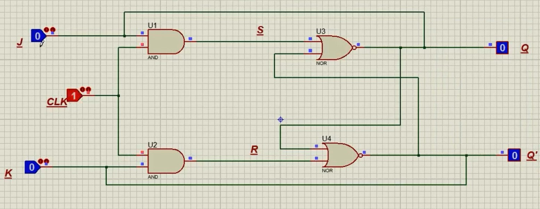
Figure 2: JK Flip-Flop using AND and NOR gates (Proteus Simulation) — J=0, K=0, CLK=1

Simulation Analysis (J=0, K=0, CLK=1):
- With J=0 and K=0, both AND gate outputs (S and R) remain LOW regardless of CLK.
- The NOR latch holds its previous state — Q=0 and Q'=0 shown on the output probes.
- This verifies the 'No Change' row of the JK truth table.
- The clock is active (CLK=1), but since J=K=0, no state change occurs.

2.8 Clocked SR Flip-Flop Using NAND Gates
The clocked SR flip-flop can also be implemented using NAND gates. In this NAND-based configuration:
- NAND gates U1 and U2 serve as the input gating stage, combining S (or R) with the CLK signal.
- NAND gates U3 and U4 form the cross-coupled SR latch.
- Since NAND gates are used throughout, the latch portion has active-LOW behavior, but the overall circuit with the gating stage produces active-HIGH S and R behavior.
- The inputs are only effective when CLK=1 (HIGH).

2.9 Circuit Simulation — Clocked SR FF (NAND Gates)
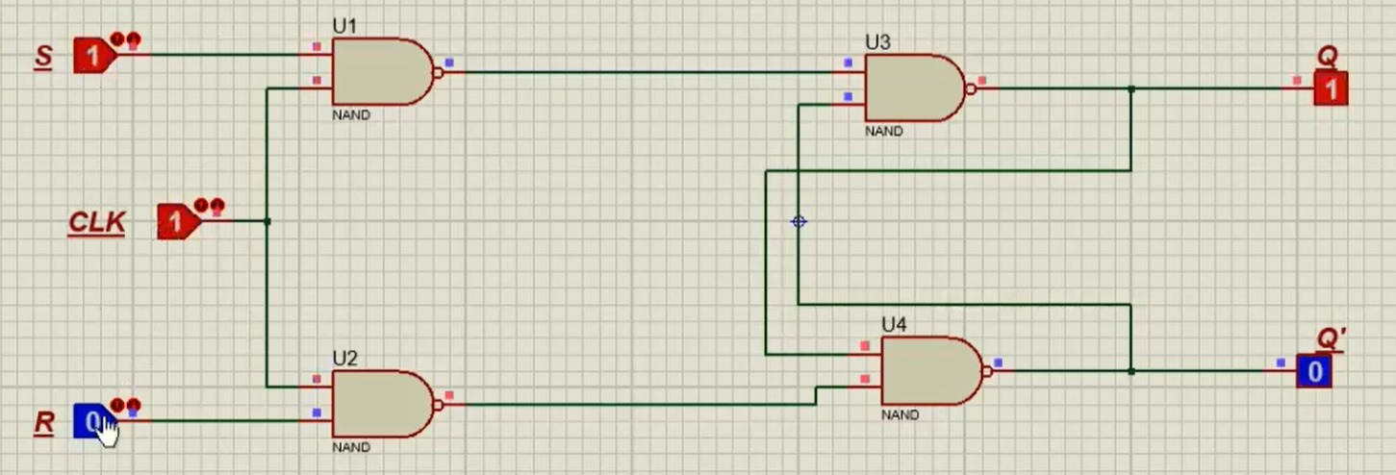
Figure 3: Clocked SR Flip-Flop using NAND gates (Proteus Simulation) — S=1, CLK=1, R=0

Simulation Analysis (S=1, CLK=1, R=0):
- S=1, CLK=1: The NAND gate U1 output goes LOW (since both inputs are HIGH), driving the SET condition into the latch.
- R=0: U2 output remains HIGH, keeping the RESET input inactive.
- Result: Q=1 (output indicator shows 1) and Q'=0 — the flip-flop is SET.
- This verifies the SET row of the clocked SR flip-flop truth table when CLK=1, S=1, R=0.

3. Equipment & Procedure

3.1 Equipment Used
- Computer with Proteus Design Suite (simulation software)
- Logic gates: NOR (74HCT02), NAND (74HCT00), AND gates
- Logic switches/probes for input/output monitoring
- LED indicators for output visualization

3.2 Procedure
Part A — NOR-gate RS Flip-Flop:
- Connect two NOR gates in a cross-coupled configuration (output of each feeds into input of the other).
- Connect S and R inputs to logic switches; Q and Q̄ to LED probes.
- Test all four input combinations: (0,0), (0,1), (1,0), (1,1) and record outputs.
- Observe memory behavior when both S and R return to 0 after being 0,1 or 1,0.

Part B — JK Flip-Flop (AND + NOR):
- Connect AND gates U1 (J, CLK, Q̄) and U2 (K, CLK, Q) as the input stage.
- Feed U1/U2 outputs into a cross-coupled NOR latch (U3, U4).
- Connect feedback: Q to U2's third input, Q̄ to U1's third input.
- Test all combinations of J, K with CLK pulse and verify the truth table.

Part C — Clocked SR FF (NAND Gates):
- Wire NAND gates U1 (S, CLK) and U2 (R, CLK) as the input stage.
- Connect their outputs into the cross-coupled NAND latch (U3, U4).
- Set CLK=0 and verify inputs have no effect; set CLK=1 and test S,R combinations.

4. Results & Observations

4.1 RS Flip-Flop (NOR Gates) — Verified Truth Table

S | R | Q | Q̄ | Operation | Observation
0 | 0 | Qₙ (hold) | Q̄ₙ (hold) | Memory | Output unchanged ✓
0 | 1 | 0 | 1 | Reset | Q goes LOW ✓
1 | 0 | 1 | 0 | Set | Q goes HIGH ✓
1 | 1 | X | X | Forbidden | Undefined state ✓

4.2 JK Flip-Flop — Verified Truth Table

CLK Edge | J | K | Q (next) | Q̄ (next) | Operation | Verified
↑ | 0 | 0 | Qₙ | Q̄ₙ | No Change | ✓
↑ | 0 | 1 | 0 | 1 | Reset | ✓
↑ | 1 | 0 | 1 | 0 | Set | ✓
↑ | 1 | 1 | Q̄ₙ | Qₙ | Toggle | ✓

4.3 Clocked SR FF (NAND) — Verified Truth Table

CLK | S | R | Q (next) | Q̄ (next) | Operation
0 | X | X | Qₙ | Q̄ₙ | Clock disabled — no change
1 | 0 | 0 | Qₙ | Q̄ₙ | Hold
1 | 0 | 1 | 0 | 1 | Reset
1 | 1 | 0 | 1 | 0 | Set
1 | 1 | 1 | Undefined | Undefined | Forbidden

5. Conclusion
This lab successfully demonstrated and verified the operation of RS and JK flip-flops through Proteus simulations:
- The NOR-gate RS flip-flop correctly exhibited Set, Reset, Hold, and Forbidden states as predicted by theory. The memory characteristic retaining the last valid state when S=R=0 — was clearly observed.
- The clocked SR flip-flop added synchronization control, ensuring state changes occur only during active clock pulses, which is fundamental to synchronous digital design.
- The JK flip-flop resolved the forbidden-state problem of the RS FF by introducing the toggle functionality when J=K=1. This makes the JK FF the most versatile flip-flop and the preferred choice in counters and state machines.
- The simulation results matched the expected truth tables for all three circuits, confirming the correctness of the designs.
- Feedback connections from the Q and Q̄ outputs back to the input AND gates in the JK FF are critical for implementing the toggle behavior.

Overall, flip-flops form the backbone of sequential logic. Their ability to store a single bit of information and change state in a controlled manner under clock and input signals is the foundation of all digital memory, counters, shift registers, and state machines.

